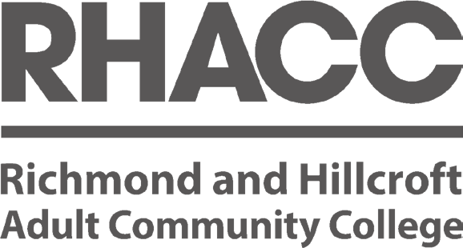

**RHACC STAFF BENEFITS**



**EXPLORE ALL THE ADDITIONAL BENEFITS OPEN TO OUR STAFF**

**SERVICE | ENTERPRISE | INCLUSION | PRIDE**

# **YOUR STAFF BENEFITS**

We recognise and appreciate the value our staff make at our college.

At RHACC we value our staff, whether they be full-time, part-time, permanent, or variable hours; we recognise the value each individual makes to our College in helping us to achieve our strategic goals, to help others in their learning.

**We have therefore, put together a number of benefits which are designed to support your needs. Which identifies our gratitude to you, for your continued support and hard work.**

Our range of benefits have been carefully selected to ensure there is something for everyone. Whether you are looking for discounts on every day items, discounted cares and holidays, needing help with some counselling service, we have something for everyone.

**Identifying new ways to support staff :**

We are always keen to provide our people with access to the most relevant discount and benefit schemes available.

If you feel there is a particular benefit you would be interested in, or you are having issues accessing any of the benefits, please contact the HR team at [hr@racc.ac.uk,](mailto:hr@racc.ac.uk) or pop in and see us at one of our weekly HR Surgeries.



## RHACC Staff Benefits:

Pensions UniDays Teacher Perks Carparking Counselling Cycle Scheme

Colleges Health Trust Costco

**SERVICE** — We provide you with our service from HR to increase your motivation, and engagement through ensuring you have full access to benefits that interest you and benefit you.

**ENTERPRISE** — We use our entrepreneurial skills to identify new and exciting benefits that will add value to all employees of the College.

**INCLUSIVE** — We ensure that all our services and offerings are accessible by all, ensuring all staff are included and able to access the benefits we offer.

**PRIDE** — We take pride in the services we provide our College, we look to ensure that the information we provide you is clear, accurate, and easily accessible.

Education

Season Ticket Loans Eye Care Vouchers Creche

Discounted Software Discounted Room Hire Discounted Gym Membership

# **PENSIONS**

We recognise and appreciate the value our staff make at our college.

We believe in helping our staff to prepare for their retirement, and we recognize the importance of ensuring that our staff are prepared and looked after in their later years. We work closely with our pension providers to ensure you receive the best possible advantages.

There are two schemes, one for academic staff, and one for non-academic staff.

Both of which provide very attractive contributions from us.

The college complies with Government legislation on auto enrolment and employees may be eligible to join or will be automatically enrolled into the relevant scheme. Both schemes are contribution based with RHACC making contributions alongside the employee.



## RHACC Staff Benefits:

Pensions UniDays Teacher Perks Carparking Counselling Cycle Scheme

**Academic Staff TPS** : Teachers Pensions scheme [www.teacherspensions.co.uk](http://www.teacherspensions.co.uk/) - We will contribute **23%** towards your pension and also includes additional benefits (such as in service death benefit).

Colleges Health Trust Costco

Education

Season Ticket Loans Eye Care Vouchers Creche

**Non-Academic Staff LGPS** : Local Government Pension Scheme www.lgps. org.uk

We will contribute **19%** towards your pension and also includes additional benefits (such as in service death benefit).

Discounted Software Discounted Room Hire Discounted Gym Membership

# **UNIDAYS**

We recognise and appreciate the value our staff make at our college.

Unidays verifies student statuses and puts exclusive deals and discounts from a variety of leading brands all in one place. You’ll find offers on food, clothing to tech, from brands like Microsoft, Apple, and Dell and much more.

If you have an academic email address (i.e. it ends .ac.uk), you can set yourself up a free UNIDAYS student account (also works on StudentBeans too using a similar process).



## RHACC Staff Benefits:

Pensions UniDays Teacher Perks Carparking Counselling Cycle Scheme

**1 . Visit UniDays**

1. **Click Join now and set up an account**
2. **Choose institution (RHACC) and choose any course and year of study.**
3. **Provide your academic/institutional email and click send email.**
4. **Verify your account by clicking through from the email you receive.**

*If you don’t get an email, follow the on screen instructions.*

Step-by-step on How to Set-Up Unidays Account:

Colleges Health Trust Costco

Education

Season Ticket Loans Eye Care Vouchers Creche

Discounted Software Discounted Room Hire Discounted Gym Membership

# **TEACHER PERKS**

We recognise and appreciate the value our staff make at our college.

Teacher Perks is a FREE sensible way for quality education businesses and organisations to get their message in front of the right people in schools. Get discounts on educational products and services, and on the high street. Keep

your finger on the educational news, get early access to educational products and services and more.



## RHACC Staff Benefits:

Pensions UniDays Teacher Perks Carparking Counselling Cycle Scheme

Colleges Health Trust Costco

**Exclusive Perks**

As a teacher or employee within a UK educational establishment, you will get access to dozens of exclusive perks.

**School Discounts**

Access special education supplier discounts for your school, college, academy, nursery, or university.

**Paid Surveys**

Earn extra money by taking part in our paid surveys, questionnaires, and research opportunities.

**Keep Informed**

Receive education-focused information about exam boards, Ofsted, curriculum changes, offers, and more.

**Edu-Charities**

We work with many education charities for free, helping them connect with schools that share their powerful educational messages.

EXCLUSIVE OFFERS INCLUDE:

Education

Season Ticket Loans Eye Care Vouchers Creche

Discounted Software Discounted Room Hire Discounted Gym Membership

# **CAR PARKING**

We recognise and appreciate the value our staff make at our college.

Our Parkshot campus has a paid carpark at the rear of the building called the Old Deer Carpark, which can cost up to £14.80 per day. Our Hillcroft site has access to

on street carparking which is free, and the Surbiton station carpark, which can cost

£12.10 per day.

To further support our staff, **we provide free carparking at both campuses (Parkshot and Hillcroft).** Though this needs to be on a first come, first serve basis. There are also a number of disabled spaces on both sites.

To be able to park on either campus, staff need to ensure that they have a valid parking pass in place and clearly displayed in their front windscreens. This allows our security teams to ensure only authorised persons are parking on site.

Available Car Parking Off-Campus:

* **OLD DEER CARPARK**
* **SURBITON STATION CAR PARK**



We recognise that not all staff commute to their workplace via public transport, even though as an organisation, we would always encourage our staff to do so, where possible.

## RHACC Staff Benefits:

Pensions UniDays Teacher Perks Car Parking Counselling Cycle Scheme

Colleges Health Trust Costco

Education

Season Ticket Loans Eye Care Vouchers Creche

**To obtain a parking pass, please email HR at** [**hr@racc.ac.uk**](mailto:hr@racc.ac.uk) **with your name, department, and car registration.**

We will email you once available for you to collect from the HR office.

Discounted Software Discounted Room Hire Discounted Gym Membership

# **COUNSELLING**

We recognise and appreciate the value our staff make at our college.

We want to ensure that all staff are fully supported and understand that sometimes, talking with your direct line manager or HR, can be difficult and sometimes you may need additional support.



**ARE YOU HAVING DIFFICULTIES WITH THE PRESSURE OF HOME OR WORK ?**

## RHACC Staff Benefits:

Pensions UniDays Teacher Perks Carparking Counselling Cycle Scheme

We have a FREE confidential employee telephone counselling service DAS, for you and your family to provide you with all the professional support and guidance you may need. Available 24hrs a day with no limit to the number of calls, you can access this service whenever you need to.

Colleges Health Trust Costco

**Contact: 0117 934 2121**

Education

Season Ticket Loans Eye Care Vouchers Creche

Discounted Software Discounted Room Hire Discounted Gym Membership

# **CYCLE SCHEME**

We recognise and appreciate the value our staff make at our college.

RHACC’s Cycle2Work is an HMRC approved salary sacrifice initiative, allowing you to hire a bike and accessories from the college for the purpose of cycling to work.

## RHACC Staff Benefits:

* On site bike racks.
* 10% staff discount at Crown Cycles, Richmond Cycles and Moore Cycles.
* One-to-one cycle training provided by Richmond Council (limited availability).
* As an extra incentive to encourage cycling, mileage expenses can be claimed for the journey to and from sites when cycling for official college business.
* As part of the redevelopment at Parkshot there will be shower and changing facilities available to staff

**OTHER CYCLING BENEFITS:**

Pensions UniDays Teacher Perks Carparking Counselling Cycle Scheme

Colleges Health Trust Costco

Education

Season Ticket Loans Eye Care Vouchers Creche

Discounted Software Discounted Room Hire Discounted Gym Membership

# **COLLEGES HEALTH TRUST**

We recognise and appreciate the value our staff make at our college.

We want to ensure that all staff access to appropriate healthcare, so that we can help protect you and your family.

As a member of the Association of College’s, staff at RHACC are fortunate enough to be able to benefit from discounted healthcare cover.

Staff can join on a voluntary basis by completing and returning the application form.



## RHACC Staff Benefits:

Pensions UniDays Teacher Perks Carparking Counselling Cycle Scheme

**Please see current monthly membership subscription rates below:**

* Member only - £ 50.00 per month
* Member and spouse/partner - £ 100.00 per month
* Member, partner and children -

£125.00 per month

* Member and children - £ 75.00 per month

Colleges Health Trust

Costco Education

Although the NHS does a sterling job and is the envy of many other countries.

However, in the majority of cases, medical conditions do not fall into this category and consequently treatment for many conditions is subject to long delays.

Avoiding lengthy waiting lists is one reason why people purchase health cover or why employers provide it for their staff.

Season Ticket Loans Eye Care Vouchers Creche

Discounted Software Discounted Room Hire Discounted Gym Membership

# **COSTCO**

We recognise and appreciate the value our staff make at our college.

Costco is an American multinational corporation which operates a chain of membership-only big-box retail stores.

## RHACC Staff Benefits:

At Costco, you’ll find everything from groceries and electronics to clothing and cleaning supplies - all in one warehouse. Including a range of ancillary services, like Optical Centre, Tyre Centre, Photo Service, Hearing Centre and Fuel Stations.

RHACC Staff are eligible for an individual membership at Costco which is a wholesale retailer. More information can be found here:

[**http://warehouses.costco.co.uk/**](http://warehouses.costco.co.uk/) **membership/**

**EVERYTHING YOU WANT, ALL IN ONE PLACE**

Pensions UniDays Teacher Perks Carparking Counselling Cycle Scheme

Colleges Health Trust

**Membership Fee - Individual :**

· Membership fee of £28.00 (plus VAT), which includes a complimentary Spouse/partner card, for a twelve

(12) month period from the month of enrolment.

· A second card is available to an individual over the age of 18, who resides at

the same address as the primary member and must come to the warehouse with the primary member. (£14.00 plus VAT).

Costco

Education

Season Ticket Loans Eye Care Vouchers Creche

Discounted Software Discounted Room Hire Discounted Gym Membership

# **EDUCATION**

We recognise and appreciate the value our staff make at our college.

As education professionals, we value ongoing development of our staff and want to provide additional benefits to working for us.

## RHACC Staff Benefits:

Staff may enrol anytime on any leisure course (non-funded) one term duration free of charge. This is limited to one course per person per year. Courses should normally be taken outside of normal working hours. Sessional staff enrolling must have a current contract during that term.

**LEISURE COURSES**

Pensions UniDays

Teacher Perks Carparking Counselling Cycle Scheme

Colleges Health Trust Costco

Education

Season Ticket Loans Eye Care Vouchers Creche

RHACC is committed to continuous professional development and aims to support staff in undertaking training directly related to their role.

Hourly paid sessional staff are paid to attend team meetings and mandatory training. Training needs are also discussed as part of annual staff appraisals and probationary reviews and teaching observations in order for the College to ensure that staff are well supported.

Discounted Software Discounted Room Hire Discounted Gym Membership

**OUALIFICATION COURSES**

Staff may join one qualification course at **50% off** of the tuition fees. Courses should normally be taken outside

of normal working hours except in exceptional cases which is subject to Line Management approval. Sessional staff enrolling must have a current contract during that term

**FREE STAFF DEVELOPMENT**

# **SEASON TICKET LOANS**

We recognise and appreciate the value our staff make at our college.

RHACC offers employees an interest-free annual season ticket loan to cover the cost of public travel between home and the workplace.

The scheme allows RHACC staff to make financial savings whilst encouraging the use of public transport wherever possible. The commuting loan scheme can also be used to cover parking costs too.

Loan repayments are paid monthly through the employee’s net pay over a set period. This is a salary sacrifice scheme which enables you to buy an annual travel card and pay for it in monthly instalments, thereby making a large saving compared to buying individual monthly tickets.

Employees have flexibility with the scheme and can set the maximum loan amount and the number of months to make the repayments.



## RHACC Staff Benefits:

Pensions UniDays Teacher Perks Carparking Counselling Cycle Scheme

Colleges Health Trust Costco

Education

Season Ticket Loans Eye Care Vouchers Creche

Discounted Software Discounted Room Hire Discounted Gym Membership

# **EYECARE VOUCHERS**

We recognise and appreciate the value our staff make at our college.

Use one of our Specsavers voucher codes to get the best deals. Specsavers has a great range of glasses, contact lenses and eyecare products. It also offers eye tests and prescriptions.

Those who actively ude Display Screen Equipment on a regular basis, can get an eye test for free.

The Optical Care eVouchers provide a full eye examination, and if needed, a pair of glasses from the £45 range, or a £45 contribution towards other frame ranges or lens options.

If glasses are not needed, a pair of non- prescription sunglasses from a selected range are provided instead.



## RHACC Staff Benefits:

Pensions UniDays Teacher Perks Carparking Counselling Cycle Scheme

Colleges Health Trust Costco

Education

Season Ticket Loans Eye Care Vouchers Creche

Discounted Software Discounted Room Hire Discounted Gym Membership

# **CRECHE**

We recognise and appreciate the value our staff make at our college.

At RHACC, we understand how stressful and challenging it can be to access childcare and work at the same time. We look to support all employees as far as we are reasonably able to do.

We have an on-site childcare facility can put many employees at ease. Daycare can be expensive and put a huge monetary strain on families, so much so that after having two or more children many families end up having at least one family member quit their job to stay

home with the children as childcare ends up costing more than what the parents are making.

RHACC has crèche facilities providing sessional day care for children aged 6 months to 5 years, which staff are entitled to use at a discounted rate.



## RHACC Staff Benefits:

Pensions UniDays Teacher Perks Carparking Counselling Cycle Scheme

Colleges Health Trust Costco

**For further information, please contact Jill Sigamoney on 07956 865**

Education

Season Ticket Loans Eye Care Vouchers Creche

Discounted Software Discounted Room Hire Discounted Gym Membership

# **DISCOUNTED SOFTWARE**

We recognise and appreciate the value our staff make at our college.

Access software can be very expensive, for example, Microsoft Office 365 can cost up to £79.99 per year, Adobe £125, Kasperski

£760! We recognise that our staff may want, or need to have access to these types of software for work.

Software4Students is an online programme providing academic and home software to students and teachers. Software companies such as Adobe,

Kaspersky and Microsoft, are available to students and teachers at massively discounted prices.



## RHACC Staff Benefits:

Pensions UniDays Teacher Perks Carparking Counselling Cycle Scheme

Colleges Health Trust Costco

You will be able to have a discount applied when using your **@rhacc.ac.uk** email address.

Education

Season Ticket Loans Eye Care Vouchers Creche

Discounted Software Discounted Room Hire Discounted Gym Membership

# **DISCOUNTED ROOM HIRE**

We recognise and appreciate the value our staff make at our college.

We are in the privileged position of having a team of high calibre staff in the

arts school. In recognition of the value that this industry experience brings to the college in terms of recruitment, networking and professional practice. We will offer access to our facilities, supporting the Art and Performing Arts Schools staff’s own practice and CPD to tutors with current contracts.

*Under no circumstances can this access hinder the delivery of curriculum or*

*any other college business.*

So, whether it is a room at Parkshot or the Boardroom at The Bridge, we can help provide the ideal solution for you.

**We are able to offer employees a discounted rate on room hire.**

**Please contact the Events and Hires Team: 020 8439 8946.**



## RHACC Staff Benefits:

Pensions UniDays Teacher Perks Carparking Counselling Cycle Scheme

Colleges Health Trust Costco

**THE BRIDGE WORKSPACE**

**Co-Working Space**

There is an affordable co-working option allowing you access to an office environment without the ties of a fixed term office.

**Private & Virtual Offices**

Rent a regular, private office space which is flexible and affordable. Virtual offices available also.

**Boardroom Hire**

We have our modern boardroom which can comfortably accommodate up to 10.

Education

Season Ticket Loans Eye Care Vouchers Creche

Discounted Software Discounted Room Hire Discounted Gym Membership

# **DISCOUNTED GYM MEMBERSHIP**

We recognise and appreciate the value our staff make at our college.

**POOLS ON THE PARK**

The corporate rate you have with ourselves is currently £45 per month with a £30 joining fee.

This includes the use of other fitness centres in the borough, including:

* Hampton Sports & Fitness Centre
* Shene Sports & Fitness Centre
* Teddington Sports Centre
* Teddington Pools & Fitness Centre
* Whitton Sports & Fitness

**Contact for more info: 020 3772 2999**



RHACC have corporate discounts for health clubs in the local area for both sites:

* Pools on the Park
* Colet’s Health & Fitness Club

## RHACC Staff Benefits:

Pensions UniDays Teacher Perks Carparking Counselling Cycle Scheme

Colleges Health Trust Costco

**COLET’S HEALTH & FITNESS CLUB**

Just 3 - months commitment for only

£35 per month.

This includes access to:

* Gym
* Classes
* Squash
* Sauna
* Gym Programmes
* Health Checks

**Contact for more info: 020 8398 7108**

Education

Season Ticket Loans Eye Care Vouchers

Creche

Discounted Software Discounted Room Hire Discounted Gym Membership

**F O R M O R E I N F O R M AT I O N E M A I L : H R @ R A C C . A C . U K**

*We also have Cannons Health club is located on the other side of the A316 in the Richmond Athletic Ground (Kew Foot Road, Richmond TW9 2SS.*

17

# **RHACC HR**



**Richmond & Hillroft Adult and Community College**

Parkshot Richmond Surrey TW9 2RE

T: 02088915907

12 South Bank Surbition Surrey

KT6 6DW

T: 02083992688

**RHACC.AC.UK**

Supporting Staff to Achieve More

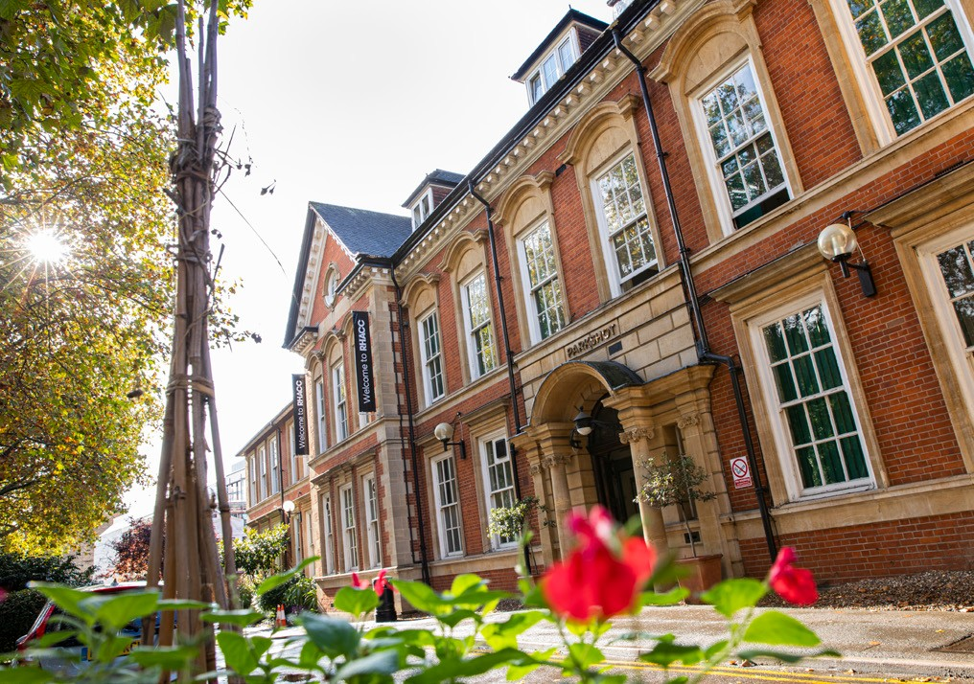**Service** - We provide you with our service from HR to increase your motivational and engagement, through ensuring you have full access to benefits that interest you.

Enterprise - We use our entrepreneurial skills to identify new and exciting benefits that will add value to all employees of the College.

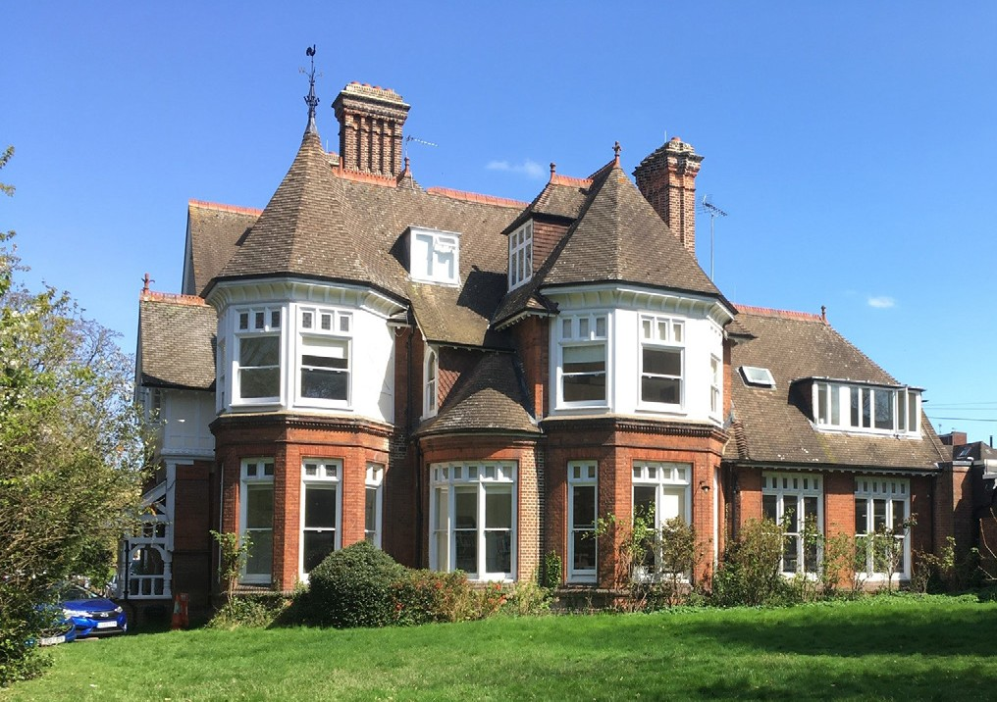Inclusive - We ensure that all our services and offerings are accessible by all, ensuring all staff are included and able to access the benefits we offer.

Pride - We take pride in the services we provide our College, we look

to ensure that the information we provide you is clear, accurate and easily accessible.